**BEHAVIOUR FRAMEWORK**

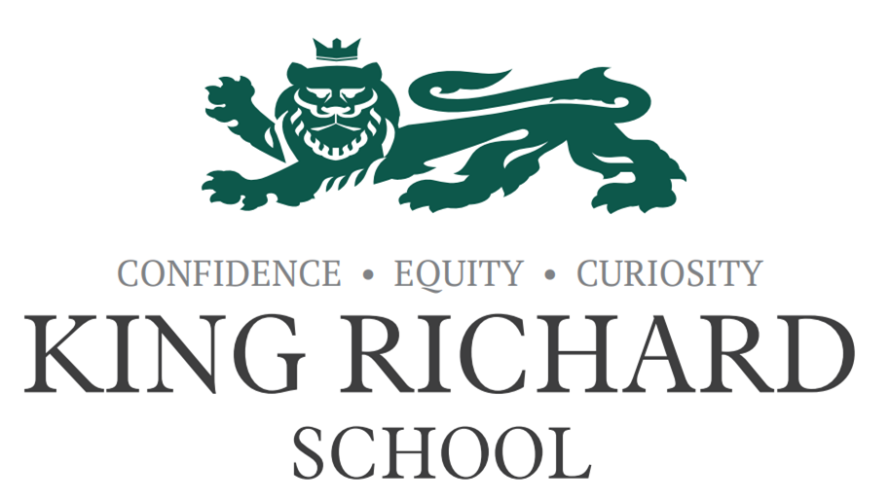

|  |  |  |  |
| --- | --- | --- | --- |
| **Approved by:** | **R Sproson** | **Date:** | January 2022 |
| **Last Reviewed:** | April 2025 | **Next Review:** | April 2026 |

**King Richard School**

King Richard School is committed to creating an environment where excellent behaviour is central to outstanding learning. We expect all members of our school community to uphold and model our Core Values of:

**Confidence** – believing in ourselves and others; having the courage to do the right thing

**Equity** – ensuring fairness, respect and opportunity for all

**Curiosity** – embracing learning, asking questions, and seeking to understand the world around us

Everyone is expected to maintain the highest standards of personal conduct, take responsibility for their actions, and encourage others to do the same. Positive behaviour is everyone's responsibility and is the foundation of a successful, inclusive, and respectful school.

**Our Approach**

This Behaviour Policy:

Guides staff to teach and support students to develop self-control and responsible decision-making

Recognises that students can, and usually do choose to behave well

Emphasises that behaviour is a choice, and consistency is essential

Aims to create a culture where students and staff respect one another, reflect our Core Values, and understand the impact of their actions

**All Staff – All the Time**

It is the responsibility of all staff, at all times and in all settings: classrooms, corridors, social spaces, and during trips and events to:

* Model positive behaviour and uphold the Core Values
* Build positive relationships with students
* Set high expectations and apply them consistently
* Use praise purposefully and effectively to reinforce the behaviour we want to see
* Address poor behaviour calmly, fairly, and without delay
* Ensure students are supported to re-engage and repair after incidents

Staff cannot control behaviour – but we can influence it through consistency, relationships, expectations, and modelling.

**All Students will…**

* Be Respectful to staff, peers, visitors, and school property
* Be Responsible for their actions, choices, and learning
* Be Ready to Learn – on time, equipped, and fully engaged
* Reflect and live out the school’s Core Values:
* Show Confidence in facing challenges and owning mistakes
* Promote Equity by treating others fairly and with kindness
* Demonstrate Curiosity by asking questions and participating actively

**All Staff will…**

* Meet and greet students at the door
* Use behaviour-informed seating plans
* Display and refer to the Core Values and rewards posters
* Model respect, resilience and emotional control
* Plan and deliver engaging, inclusive lessons
* Use positive reinforcement and praise
* Remain calm and offer students ‘take-up time’ before sanctions
* Follow up incidents with restorative conversations
* Never walk past poor behaviour – in class, corridors or social times

Positive behaviour is a shared professional responsibility – not the domain of individual staff, departments or roles.

**Addressing Harmful Behaviours**

King Richard School has zero tolerance for:

* Cyberbullying
* Prejudice-based and discriminatory bullying (racist, sexist, homophobic, transphobic, ableist, etc.)
* Child-on-child abuse (including emotional, physical, sexual harassment, violence or coercion)
* These behaviours directly oppose our Core Value of Equity, and breach our standards of Respect, Responsibility and Readiness to Learn.

All incidents will be treated seriously, and actions will include:

* Immediate reporting via MyConcern
* Investigation by pastoral or safeguarding staff
* Support for the victim and clear, consistent consequences for perpetrators
* Involvement of parents/carers
* Referral to external agencies as required
* Follow-up and curriculum-based learning where appropriate

**All staff are trained to:**

* Recognise the signs of bullying or abuse
* Act immediately and proportionately
* Ensure that students feel safe, heard and supported

**Consistency and Culture**

* Consistent language: clear, calm and linked to the Core Values
* Consistent routines: meet and greet, behaviour steps, positive reinforcement
* Consistent expectations: no lowering of standards; equity, not uniformity
* Consistent follow-through: always act, always reflect, always restore

**Behaviour Steps – Supporting Change**

1. The Reminder

Private prompt: “Are you showing Confidence, Equity, or Curiosity right now?”

Reminds students of their role and choices

2. The Caution

Calm, clear warning with potential consequence

Emphasise previous positive behaviour and capacity to succeed

3. Cooling Off

Short time away from peers (within view or nearby)

Boundaries reset, expectations clarified, support offered

4. The Sanction

If behaviour continues, consequences are implemented

For serious behaviour (abuse, defiance, violence), immediate sanction may be necessary

**Referrals & Support**

If behaviour:

* Disrupts learning repeatedly
* Involves safety risks, threats or abuse
* Fails to improve over time despite support

… staff should:

* Seek support from Middle Leaders / SLT
* Record incidents via MyConcern
* Engage in repair meetings with the student (with support if needed)
* Contact parents/carers and agree a plan for improvement
* Implement pastoral support or behaviour reports where needed

**Use of Reasonable Force**

Staff are advised to avoid physical intervention where possible. Reasonable force may only be used to prevent serious harm. If used:

* Complete an incident form immediately
* Inform SLT the same day
* Consider the child’s needs and use de-escalation strategies whenever possible
* Follow DfE Guidance on Reasonable Force

**Rewards and Positive Reinforcement**

We celebrate effort, progress and living out the Core Values.

Methods include:

* Epraise points
* Positive phone calls, emails, notes
* Recognition in assemblies, tutor time, and newsletters
* Spontaneous and sincere verbal praise
* “Catch students being good – and let them know you see it.”

**Conclusion**

This Behaviour Framework promotes a safe, inclusive and aspirational culture based on Confidence, Equity and Curiosity.

* It is not only a system, but a shared mindset.
* Every member of staff is responsible for:
* Supporting positive behaviour
* Challenging poor conduct
* Modelling emotional control
* Upholding our Core Values in every space, with every student